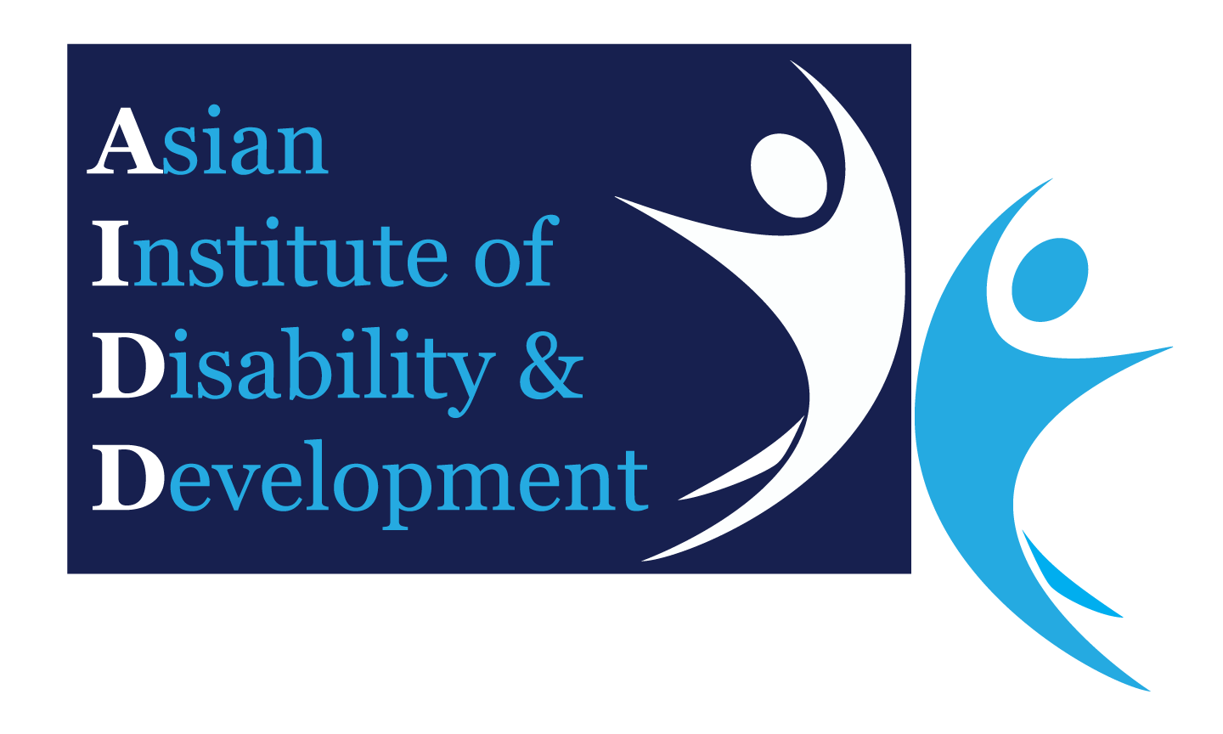Ethical Approval Application

To Asian Institute of Disability and Development (AIDD) Ethics Committee

(Electronic Format Only)

|  |  |
| --- | --- |
| Date: | DD / MM / YYYY |

This application must be typewritten. If the space available is not sufficient, attach details on a separate sheet. If this project includes any information of a commercial or patentable nature, this information should be sent separately and marked “Confidential”. Please submit in electronic format to ***disabilityasia@gmail.com***

You can submit the approved participant information sheets and consent forms. Please also submit the approval letter in electronic format to ***disabilityasia@gmail.com***

|  |  |  |  |  |  |  |
| --- | --- | --- | --- | --- | --- | --- |
| **Project Title:** | Assessment of quality of antenatal care provided to pregnant women receiving health care in union level health and family welfare centers in the selected union of Golapganj Upazila in Sylhet district. | | | | | |
| **Names(s), Titles(s), Qualifications, Dept/Locations and Contact Details** | | | | | | |
| **Principal Investigator:** | | Khaleda Habib, Student ID# 191-0022-011, Mobile# 01741597899, e-mail address: [khaleda2010_habib@yahoo.com](mailto:khaleda2010_habib@yahoo.com) | | | | |
| **Associates and Co-Investigator:** | |  | | | | |
| **Proposed Date of project commencement:** | | | | January 2020 | | |
| **Proposed Duration of Project:** | | | | April 2020 | | |
| **Give a succinct but comprehensive aims, hypotheses and potential significance of the project, or of its other purposes, noting also the expected benefits** | | Research questions: How to assess that quality of antenatal care has ensured among the pregnant women receiving health care from those health facilities in the Union of Sylhet district.  Objective: To assess the quality of antenatal care among pregnant women  Hypothesis: The objectives of this study are to describe the coverage and content of ANC contacts in the context of rural hard to reach union level health facilities in Sylhet. This study will bring an opportunity to strengthen the health systems in union level health facilities of Sylhet through assess the different contents of quality antenatal care among the key beneficiaries (pregnant women) are receiving health services during pregnancy i.e. basic indicators of ANC (Weight taken, BP measure, Urine sample collection, Blood sample collection & Inform about danger signs) and cordial behavior from providers including proper counseling etc. | | | | |
| **Give a succinct but comprehensive statement of the scientific background to the project and project plan** | | Antenatal care (ANC) has long been considered a critical component of the continuum of care for women during pregnancy, with the potential to contribute to the survival and thriving of women and newborns [2]. This essential service allows women to be screened during their pregnancies for pre-existing conditions and potential complications, allows for initiation of timely and appropriate treatment, and provides a platform for women to receive counselling, which can support them to protect their health and that of their baby throughout the antenatal, birth and postnatal periods. Moreover, ANC is becoming increasingly important as a service as the world undergoes an obstetric transition. In this transition, preventable maternal mortality is becoming predominantly the result of indirect causes and non-communicable diseases, which requires more individualized care. ANC can provide an optimal platform for catering the individual care by screening and timely management. Promisingly, utilization of ANC has been increasing steadily throughout the past decades, with 86% women worldwide now attending at least one ANC contact and 62% receiving at least four ANC contacts between conception and birth. However, even as ANC utilization has increased over the past two decades, the content and quality of this care have fallen under increased scrutiny, as poor quality compromises the potential benefits of care. With the new targets set out in the Sustainable Development Goals (SDGs) aiming to reduce maternal and newborn deaths to unprecedented levels, and the ambitious ‘Survive, Thrive, Transform’ agenda of the Global Strategy for Women’s, Children’s and Adolescent’s Health, ensuring the quality of maternal and newborn health (MNH) services, including ANC, is as important as ever.  The World Health Organization (WHO) recently updated its ANC guidelines based on the global evidence base [1]. The new guidelines are notable in their adoption of a human rights-based approach and a focus on people-centered care. This emphasizes not only clinical service provision but also the experience of care; so that adolescent girls and women are able to benefit from a positive pregnancy experience. Moreover, it is now recommended that each woman attend eight of more routine ANC contacts between conception and birth, rather than the four or more suggested by the previous model [1]. The new guidelines are more expansive and comprehensive than the previous model, and clearly have the potential to improve the pregnancy experience and outcomes. During the Millennium Development Goals-era, the global coverage of ANC contacts inched forward, but many countries struggled to ensure adherence to the recommendations contained in the previous model. Based on this experience, it will be challenging for the countries with limited resources to ensure the adherence to the more comprehensive recommendations. A number of studies have explored the degree to which the recommended content of ANC contacts are adhered to in different countries. In general, these studies demonstrate the poor status and existing gaps related to the content of ANC contacts, even in the context of high-resource settings, much less in low and middle-income countries (LMICs).  Bangladesh has made impressive gains in reducing maternal and neonatal mortality over the past several decades, but total number and rates of these deaths remain too high. Moreover, the latest Bangladesh Maternal Mortality Survey suggests that progress in reducing maternal mortality has stalled. Use of key MNH services remains critically low. Indeed, only 37% pregnant women attend at least four ANC contacts, 47% of births occur in health facilities and 48% (6% in the case of home-based births) of women receive postnatal care from a skilled health-care professional within the first two days after birth. While the BMMS-2016 revealed that use of skilled health services during pregnancy has increased over the past decade, this has not translated into an expected reduction in maternal mortality between 2010 and 2016. This suggests that focusing solely on increasing coverage of these services is not sufficient to translate into improved health. The content and the quality of these contacts must also be ensured [1] | | | | |
| **Briefly describe all methodology to be used with participants** | | 1. Conceptual framework: Within the context of maternal and newborn health, WHO defines quality of care as ‘the degree to which maternal and newborn health services (for individuals and populations) increase the likelihood of timely, appropriate care for the purpose of achieving desired outcomes that are both consistent with current professional knowledge and take into account the preferences and aspirations of individual women and their families,’ (p. 15).[7](https://bmjopen.bmj.com/content/9/4/e024130#ref-7) Based on the guideline and supplemented by the findings from the scoping review, customized WHO’s framework for quality maternal and newborn health care[7](https://bmjopen.bmj.com/content/9/4/e024130#ref-7) so that it focuses on routine ANC. We designed the framework by grouping similar measures for assessing, improving and monitoring ANC. Needed ANC measures, both existing and non-existent, are mapped by recommendation to the framework’s domains; thus, the framework only includes health system building blocks that align with the new ANC recommendations [3].      1. Study objective:    * General objective: To assess the quality of antenatal care among pregnant women.    * Specific objective: - To assess the satisfaction among women on the quality of antenatal care they are receiving from UHFWCs.  * To assess the communication between service providers and pregnant woman * To assess the physical facilities are available for service delivery in order to ensure the quality of antenatal care  1. Study design: A facility based cross-sectional method will be applied as design. Questionnaire, observation tools will be used to collect data. 2. Target population and sample population: Pregnant women who are receiving health care services from union health and family welfare centers (UHFWCs) and the permanent residents of the unions under Golapganj upazila will be targeted and take as sample whether they are delivered the quality health services. 3. Study site and area: One sub-district (Golapganj) in Sylhet district will be targeted for the study. Data will be collected from the pregnant women are receiving health care from five (5) selected union level Govt. health facilities i.e. UHFWCs on the quality antenatal care, availability of medical equipment/logistics and its functionalization, ANC register will be taken for the study. 4. Study period: Study will be commenced from January to April, 2020. 5. Sample size: The sample size is 379 using the theory i.e. n=  |  |  | | --- | --- | | n = | Z 2 * pq | |  | | d 2 |  1. Inclusion criteria: This review will be focused: a) Pregnant women; b) People who are intended to take part in the study. 2. Exclusion criteria: The study will exclude: a) Women who are not pregnant; b) Pregnant women in case of not willing to participant in the study and in regards of physically disabled or mentally retarded. 3. Sampling technique: Observation, Convenience sampling will be used for sampling to collect data from the selected FWCs. 4. Data management and analysis plan: This study will be involved to collect data through a) secondary data source; b) questionnaire for exit interview; c) observation of availability and functionalization of medical equipment/logistics; d) SPSS version will be used for analysis data. 5. Quality control and quality assurance: The PI will be responsible for overall quality assurance. Detailed protocols for extracting data from secondary sources will be developed. Quality will be assured through routine monitoring by the lead researcher. 6. Ethical considerations:  * This study ensures not harm the research participants in any way whatsoever and respect of the participants will be given priority. All study participants will be fully informed that their participation is voluntary and that they have the right to withdraw from the study at any time. They will also be informed that refusal to participate in the study would not involve any penalty. Written and informed consent will be obtained from each participant once they are fully informed. Privacy, anonymity and confidentiality of the participants will strictly be maintained during data collection and analysis. * Will take ethical approval from University of South Asia (UNISA)  1. Limitations of the study:  * The potential of recall bias might have an important limitation of this study. Based on the pregnancy outcomes, the women’s recall regarding ANC contacts and content might have changed. * Budget and time constrain are also the limitation for this study. * Language barrier might happen because study data will take from Sylhet district. * Study population i.e. pregnant women might feel sick or discomfort.  1. Expected outcomes: Ensuring adequate coverage of ANC and maintaining adherence to the recommended ANC guidelines has the potential to save the lives of women globally and contribute towards achieving the ambitious targets encompassed by the SDGs. This study will demonstrate that coverage of ANC remains poor in union level in Sylhet district, Bangladesh, both in terms of timing of initiation of ANC and in the number of contacts. Moreover, glaring gaps remain in the content of the care received which women access these services. Therefore, it is recommended that overcoming barriers to health services access be prioritized and well as efforts to ensure the content and the quality of ANC, so that women throughout Bangladesh are able to fully benefit from these services and realize their rights to health [2]. | | | | |
| **Give a statement of the possible dangers or ill effects of these procedures and the precautions to be taken to prevent or minimize them** | | Participants will not face any potential risks from this study and participants will not loss anything providing the information. | | | | |
| **Give a statement on the demands, inconvenience or discomfort to the participants** | | No discomfort or inconvenience will happen with the participants by participating in the interview. | | | | |
| **Give the number, type and age range of all the participants, including controls** | | Sample size : 70-100/, target: pregnant women | | | | |
| **Sources and means of recruitment** | | Five (5) Union level Health and Family Welfare Centers (UHFWCs) in Golapganj Upazila of Sylhet district | | | | |
| **Will any special relationship exist between the recruiter and the participants?** | | N/A | | | | |
| **Criteria for exclusion** | | * Women not pregnant during study period * Target population not intended to take part in the study * Pregnant women might not feel better to participate due to physical or mental illness/disability | | | | |
| **Details of any proposed payment to participants** | | No payment is require for participating in the interview | | | | |
| **Where will the procedures involving participants be undertaken?** | | Selected Union Health and Family Welfare Centers (UHFWCs) in Golapganj Upazila of Sylhet district | | | | |
| **How will risk factors be minimized?** | | There is no risk factors will existent in this study | | | | |
| **How will information be handled to safeguard confidentiality both during and after completion of the research project?** | | Study information will be kept in a locked place and analysis record will be retained in laptop maintaining password. | | | | |
| **If the project involves use of medication/drugs/ procedure, give details:** | | No medicine will use for conducting the study. | | | | |
| **Has this project been submitted to any other Ethics Committee?** | | | | | □ Yes □ No | |
| **If yes; name of committee**  *(please attach a copy of approval)* | | |  | | | |
| **Approval granted?** | | | □ Yes □ No | | | |
| **What do you think are the ethical issues raised by the proposed project considering your previous answers?** | | |  | | | |
| **Please state your response to them** | | |  | | | |
| **OBTAINING INFORMED CONSENT**  Please note a copy of the explanatory material/information sheet which will be shown to the subjects and the consent form **must be included**. | | | | | | |
| **Who will explain the project to the potential participants?** | |  | | | | |
| **Is there a special relationship between the person explaining the project, or any of the investigators, and the participants?** | |  | | | | |
| **When will the explanation be given?** | |  | | | | |
| **Will the participants be able to give consent themselves?** | | | | | | □ Yes □ No |
| **If not, why? To whom will the project be explained and who will give consent?** | |  | | | | |
| **Will written consent be obtained from all participants?** | | | | | | □ Yes □ No |
| **If not, please give reasons?** | |  | | | | |
| **Who will act as witness?** | |  | | | | |

1. World Health Organization, 2016, [WHO recommendations on antenatal care for a positive pregnancy experience 2016](https://www.who.int/reproductivehealth/publications/maternal_perinatal_health/anc-positive-pregnancy-experience/en/)
2. <https://journals.plos.org/plosone/article?id=10.1371/journal.pone.0205149>
3. <https://bmjopen.bmj.com/content/9/4/e024130>